Data Analysis Project:

1. Create a problem statement.
2. Identify the data you want analyze.
3. Explore the data and clean the data.
4. Analyze the data to get useful insights.
5. Present the data in terms of reports and useful dashboards for visualizations.

**Business Problem:**

In recent years, city hotel and resort hotels have seen high cancellation rates. Each hotel is now dealing with a number of issues, as result, including fewer revenues & less than idea hotel room use. Consequently, in lowering the cancellation rates is both the hotel’s primary goal in order to increase their efficiency in generating revenue, and for us to offer through business advice to address this problem.

The analysis of the hotel booking cancellations as well as others factors that have no bearing on their business and the yearly revenue generation are the main topics of this report.



Hotel Bookings

**Assumptions:**

* **No Unusual occurrence between 2015 and 2017 will have a substantial impact on the data used.**
* **The information is still current and can be used to analyze a hotel’s possible plans in an efficient manner.**
* **There are not unanticipated negative to the hotel’s employee’s any advised technique.**
* **The hotels are not currently using any suggested of the solutions.**
* **The biggest factor affecting the hotel’s effective earnings is the booking cancellations.**
* **The cancellation result in vacant room for booked length of time.**
* **The clients make reservations the same year they make cancellations.**

**Research:**

* **What are the variables that affects hotels reservations cancellations.**
* **How can we make hotel reservations cancellations better.**
* **How will hotels have assisted in making hotels pricing and promotional decisions.**

**Hypothesis:**

* **More cancellations when prices are higher.**
* **When there is longer waiting list, the customer tends to cancel more frequently.**
* **The majority of the clients are coming from offline travel agents to make their reservations.**

**Analysis & Finding**

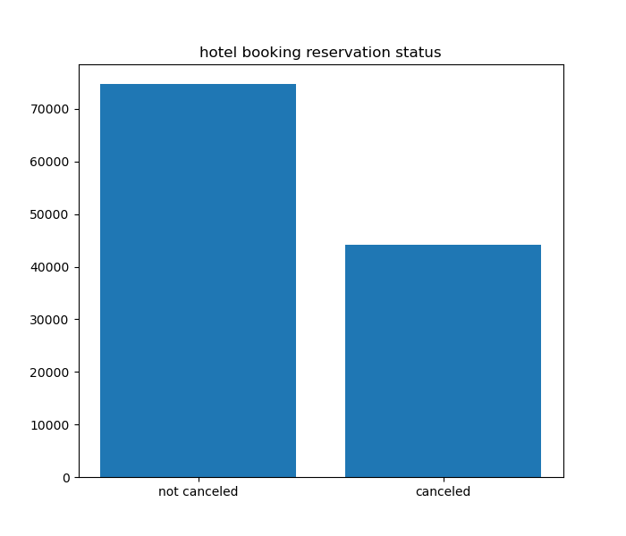

**The accompanying bar graph shows the percentage of reservations that are canceled and those are not. It is obvious that there are still a significant number of reservations that have not been canceled. There are still 37% of clients who canceled their reservation, which has a significant impact on hotel’s findings.**

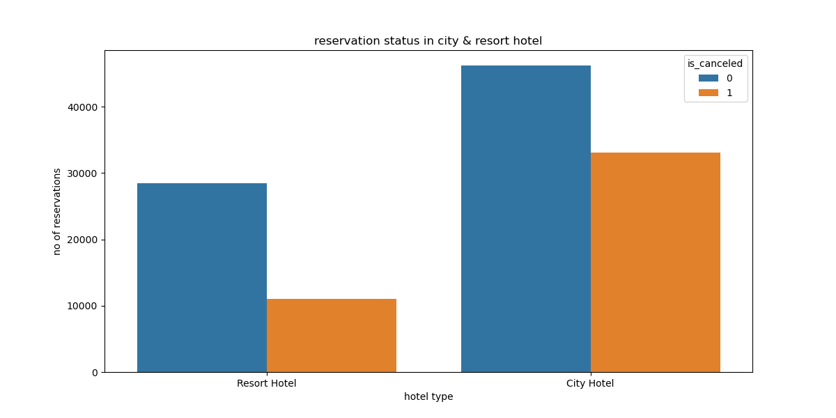

**In comparison to resort hotels, city hotels have more reservations. It is possible that resort hotels are more expensive than the city’s hotels.**

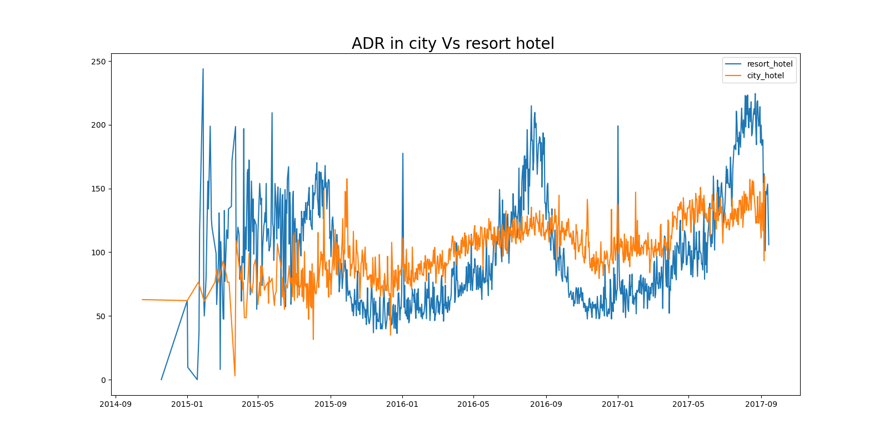

**The line graph above shows that, on certain days, the average daily rate for a city hotel is less than that of a resort hotel, and on the other days, it is even less. It goes without saying that weekends and holidays may see a rise in resort hotel rates.**

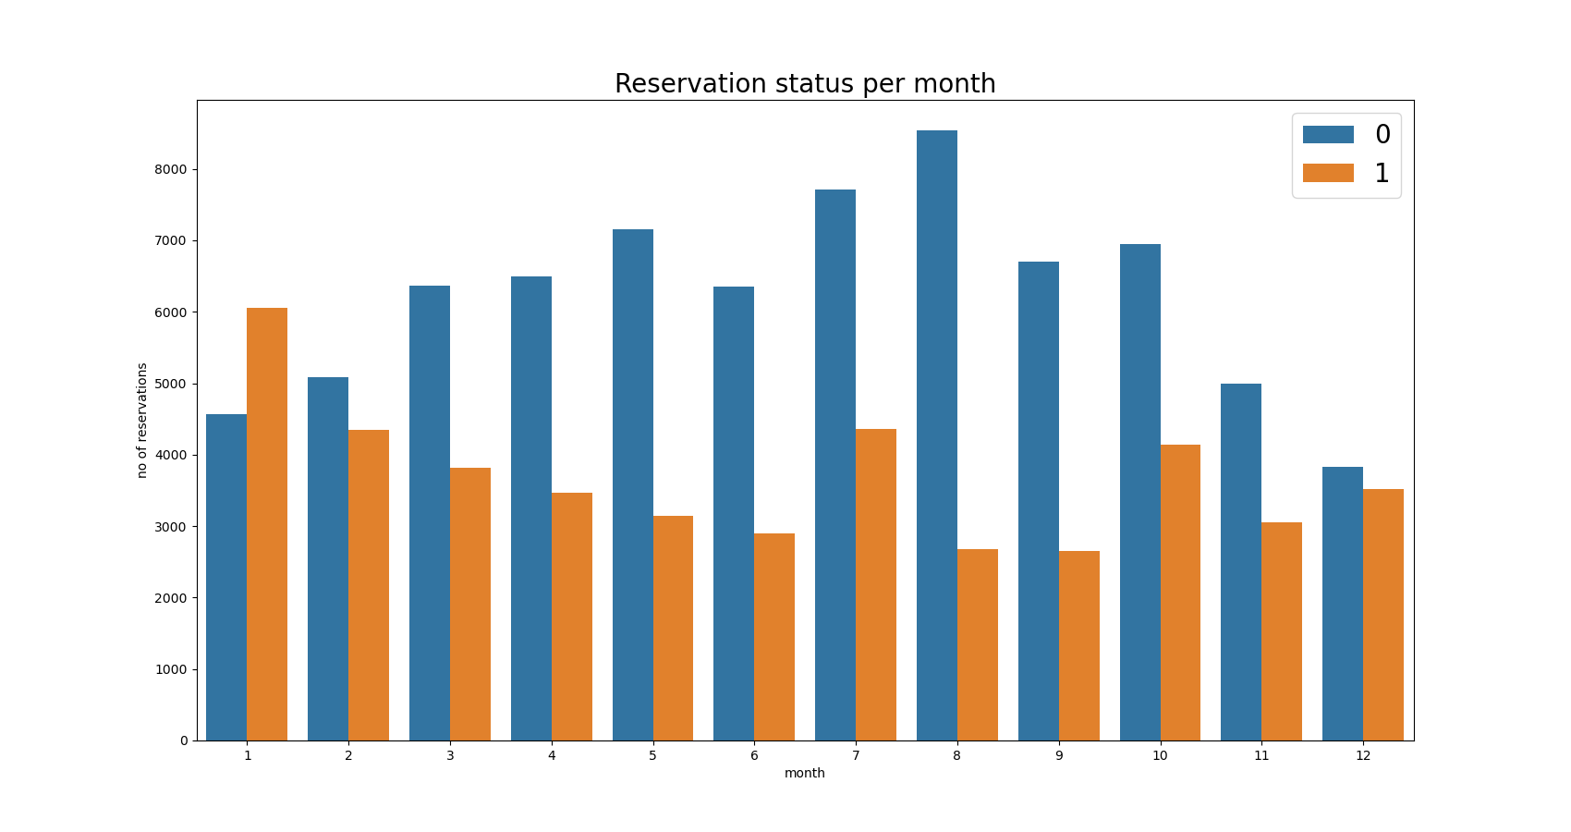

**We have developed the grouped bar graph to analyze the months with the highest & lower reservations levels according to reservation status. As we can see, number of confirmed reservations are largest in the month of August. Where has in the month of January with the most canceled reservations.**

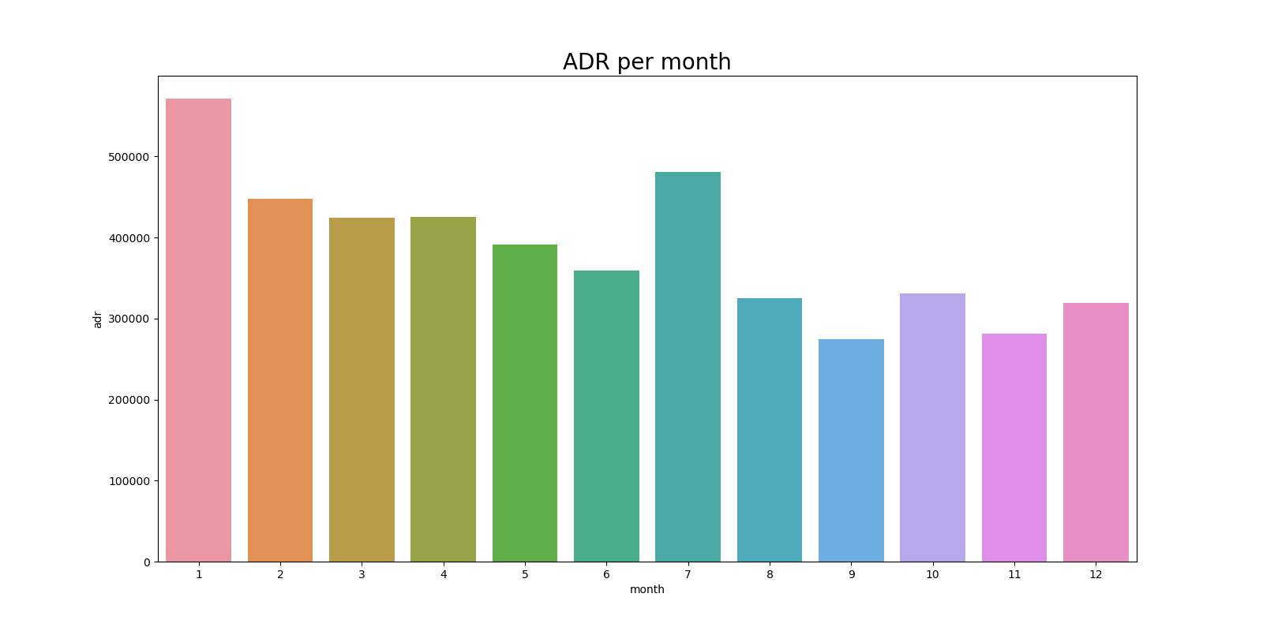

**This bar graph demonstrates that cancellations are most common when prices are greatest and are least common when they are lowest. Therefore, the cost of the accommodation is solely responsible for the cancellation.**

**Now let’s see which country has the highest reservation cancelled. The top country is Portugal with the highest number of cancellations.**

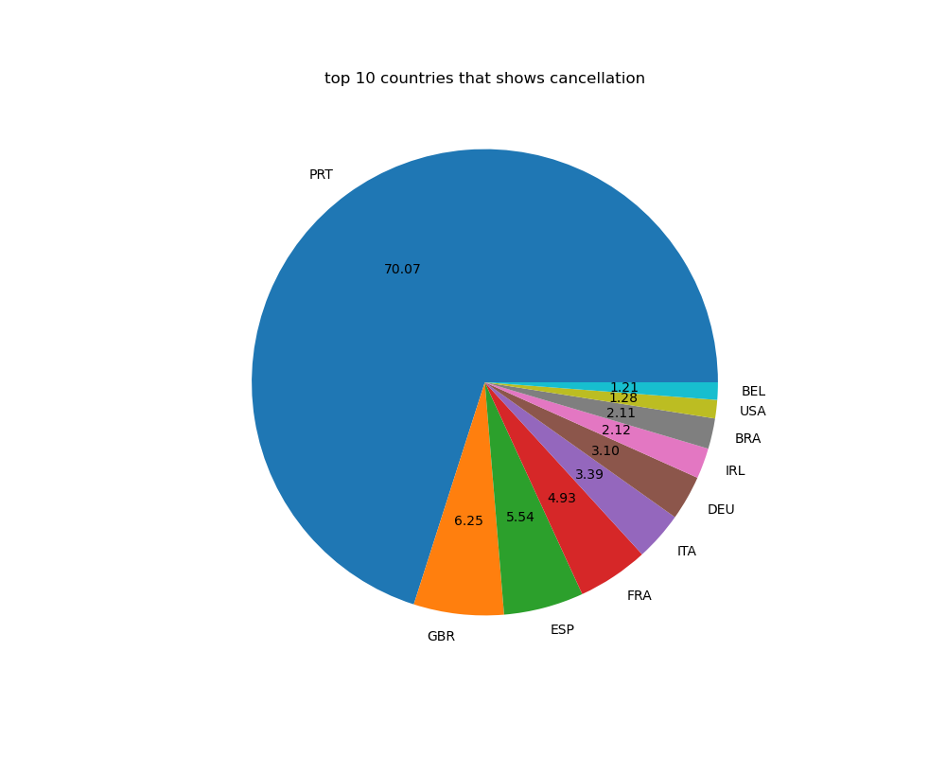

**Let’s check the platform through which clients are making reservations or visiting the hotels. Around 46./. of the clients come from through online travel agencies, whereas 27./. come from groups. Only 4./. of clients book hotels directly by visiting them and making reservations.**

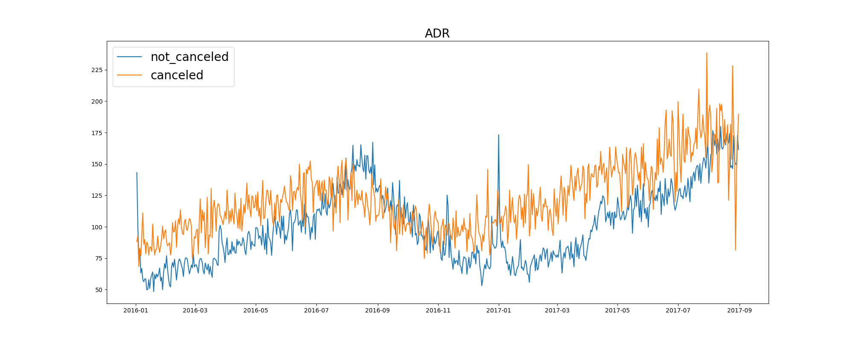

**Through the above graph we can see that reservation are cancelled more when the ADR is higher than that of when ADR is lesser. It is clearly proves all the analysis, that the higher prices leads to higher cancellation.**

**Suggestions**

* **As the cancellation are higher when the price is higher so we can the pricing strategies like giving discounts and try to lower the rates based on locations as well.**
* **We can see the cancellations rates are higher in resort than that of city hotels. Then we can try to lower the price in resort hotels especially on weekends or holidays.**
* **In the month of January, hotel can focus more on campaigning or marketing with reasonable amount to increase their revenue as the cancellation is the highest in this month.**
* **They can also increase the hotel’s the quality of their hotel’s and their service in the Portugal area as the hotel’s in Portugal country generating due to high cancellation.**